DYNAMO DB AWS

**Amazon DynamoDB** is a **fully managed NoSQL database service** offered by AWS. It's known for:

* **High performance and scalability**
* **Automatic replication**
* **Flexible data model**
* **Low-latency** access
* 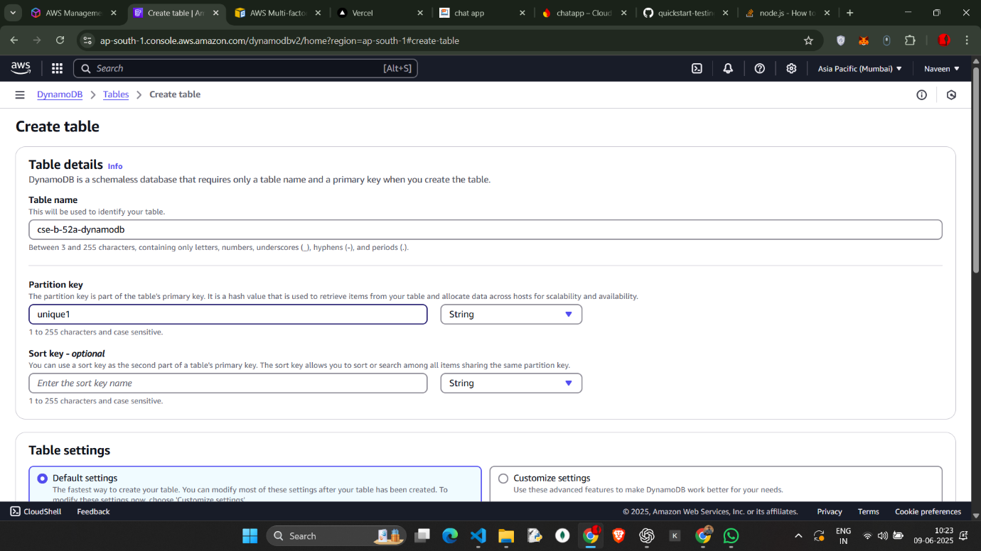

Create the table   
name cse-b-52a-dynamodb

GO to Explore items

Create item with name FS and add attributes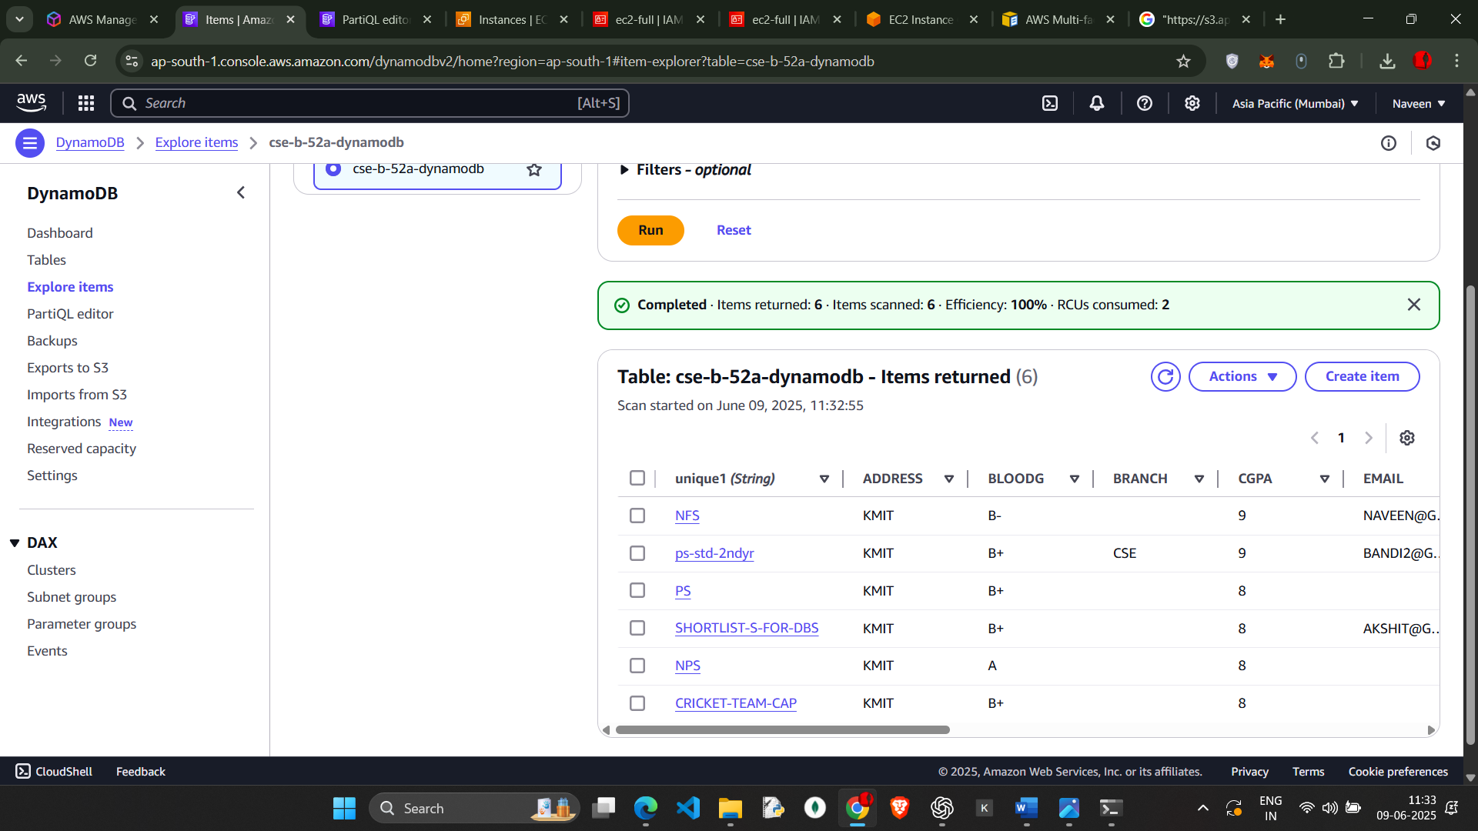

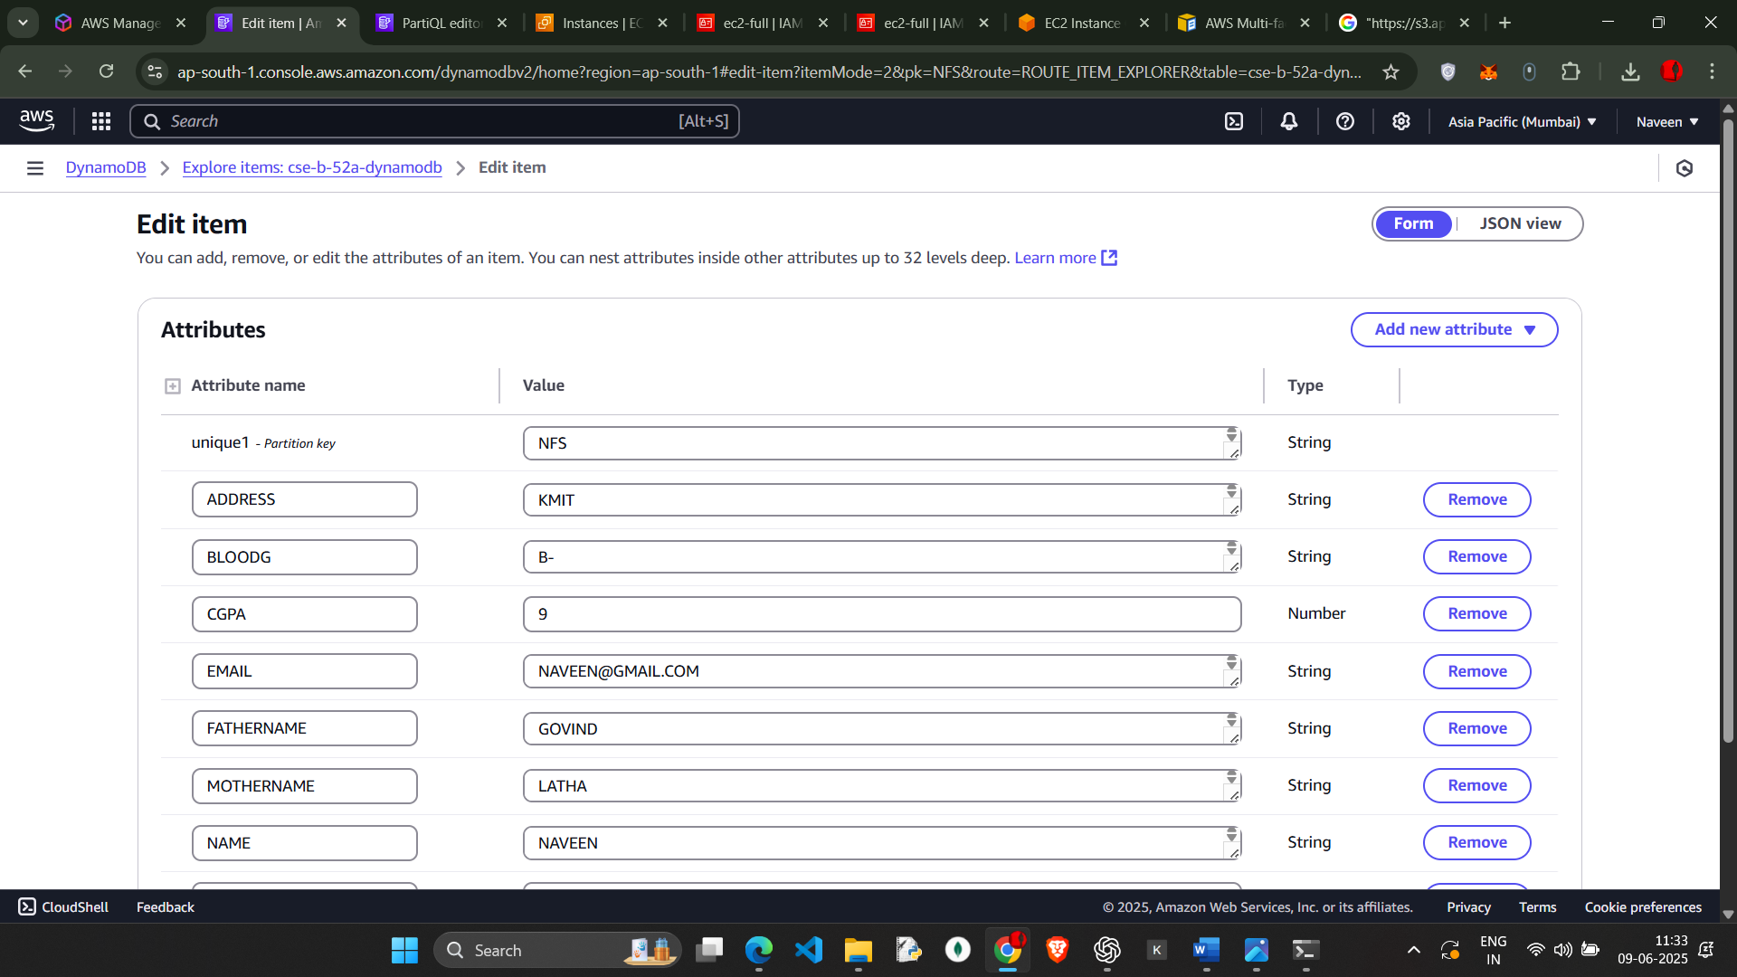

Go to json view

And edit the attributes and we can also add the attributes

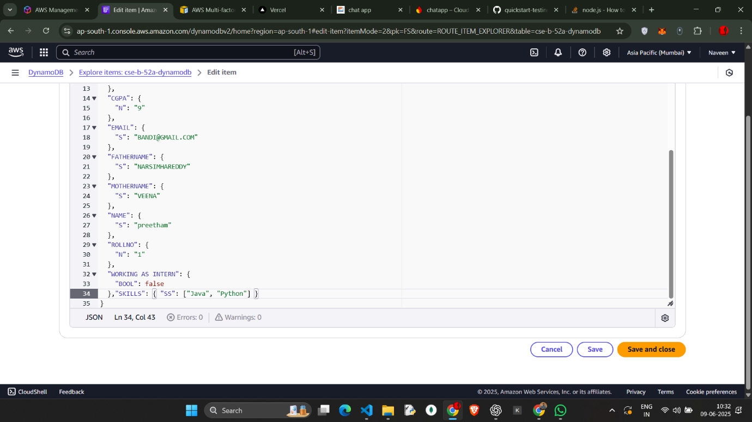

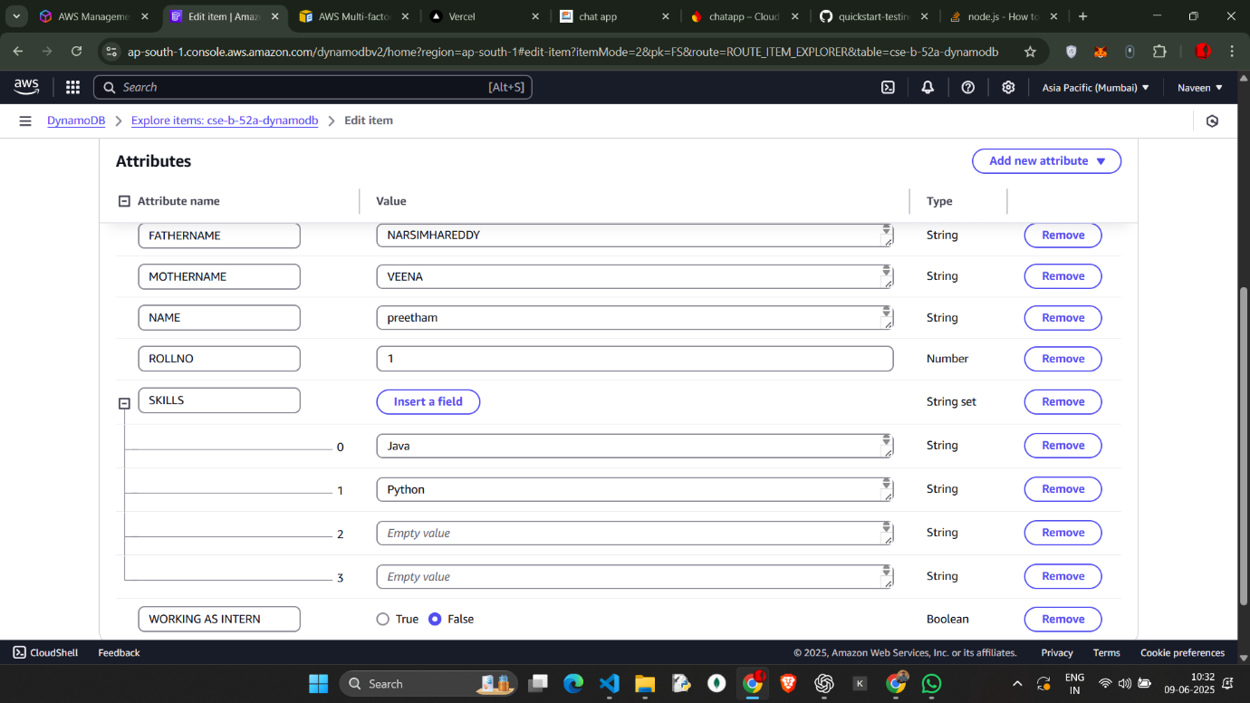

Attribute Skills is added to the form

Similarly create more tables and add attributes in the form and edit in the json view

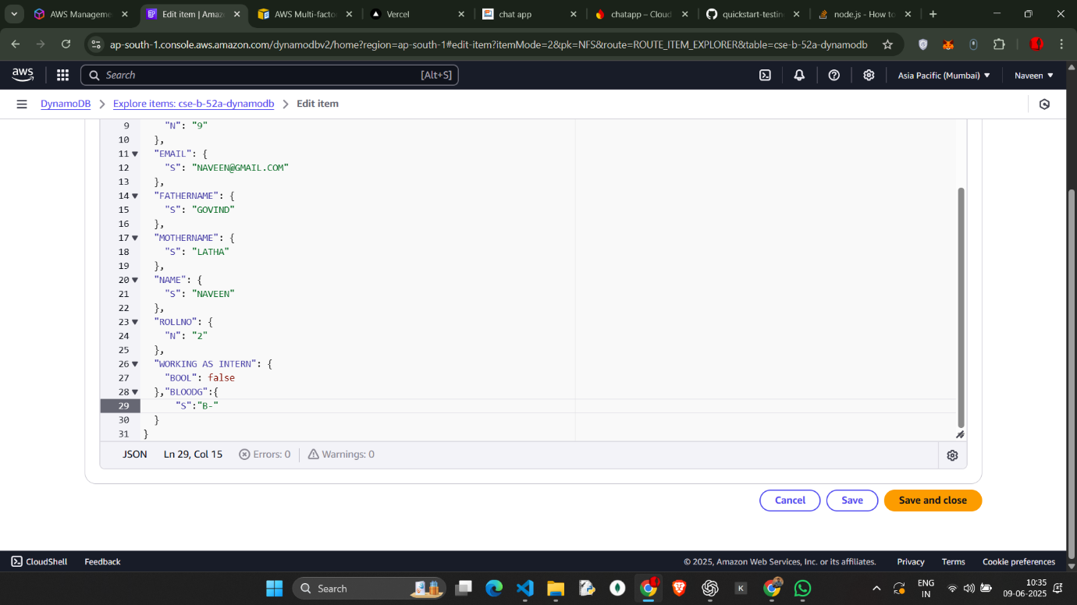

Nfs item and its attributes

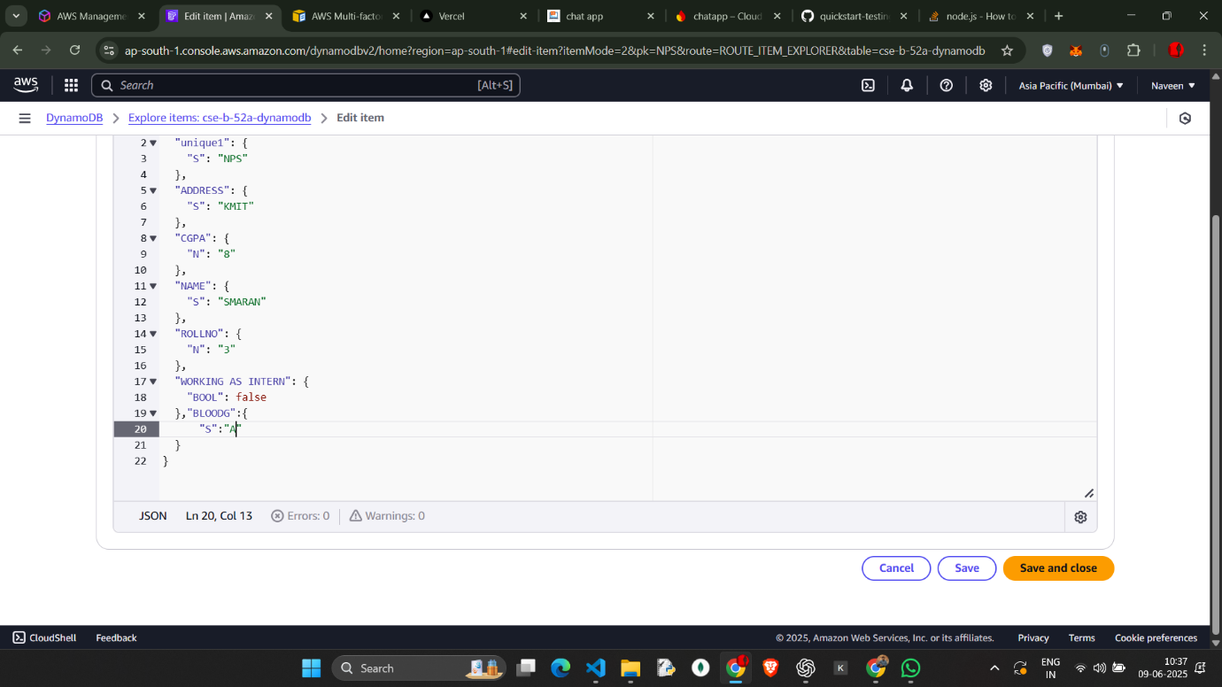

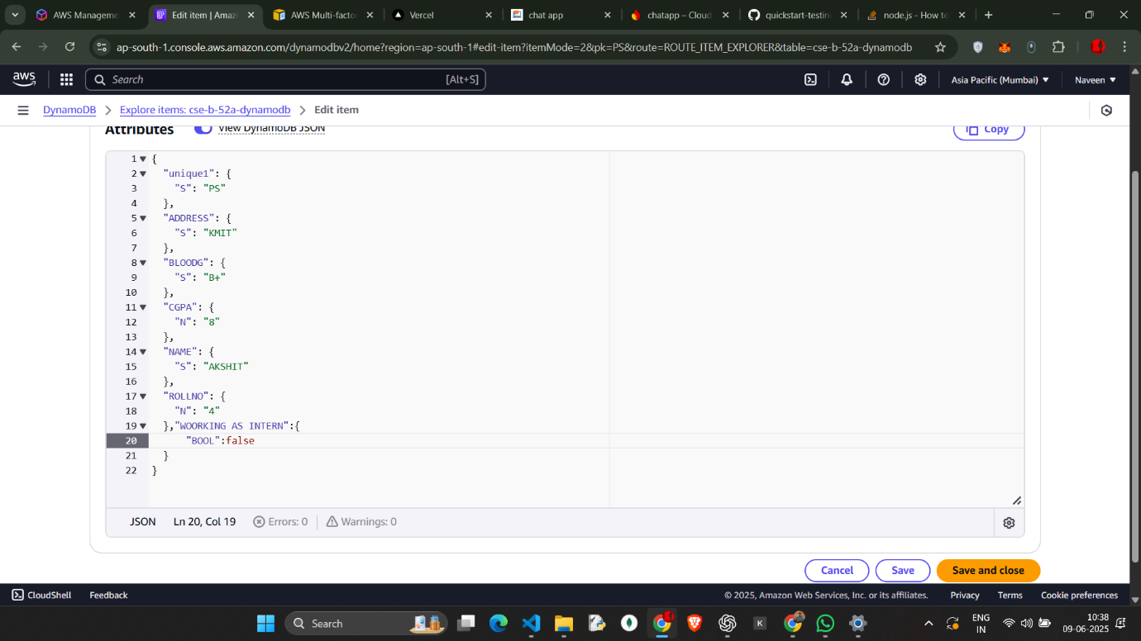

Ps item and its attributes

Nps item and the attributes in it

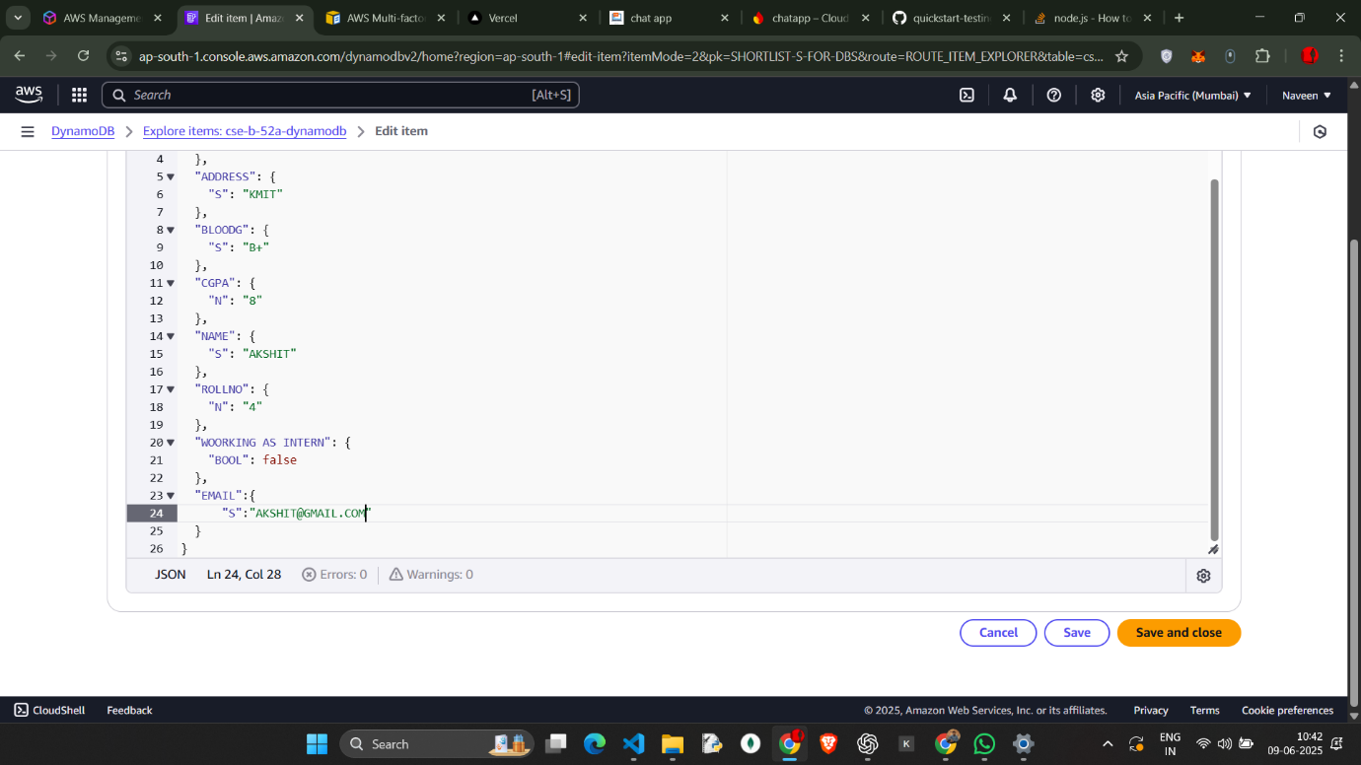

Item name : team cap add the attributes of the student and edit the attributes in the view json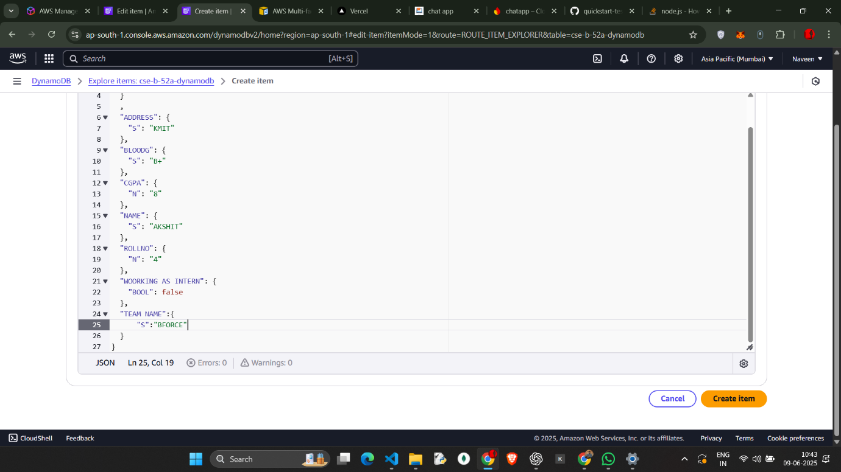

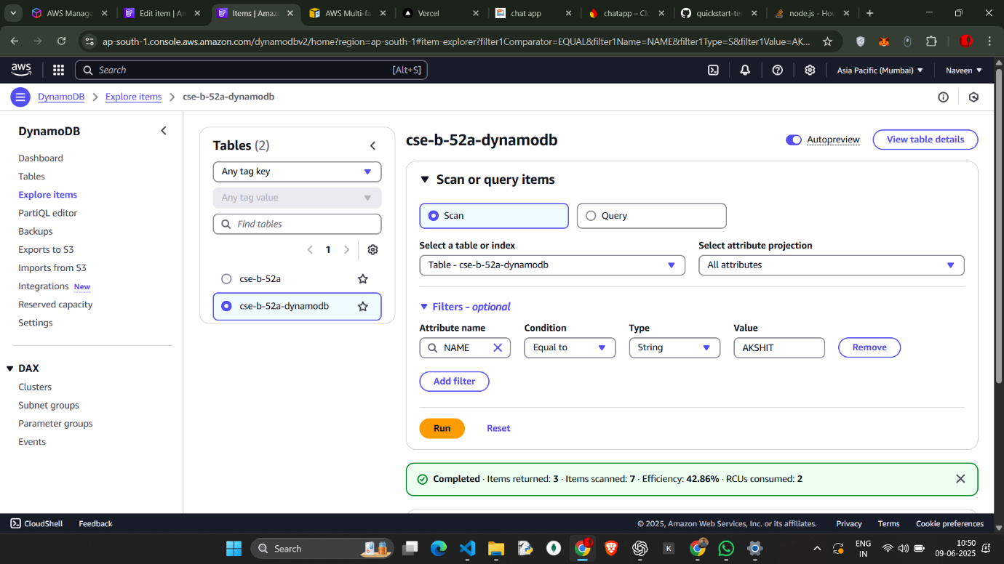

Scan the table

Select the table name and in filter options   
select attribute name and the condition ,type and the value   
attribute is name and the value is akshit

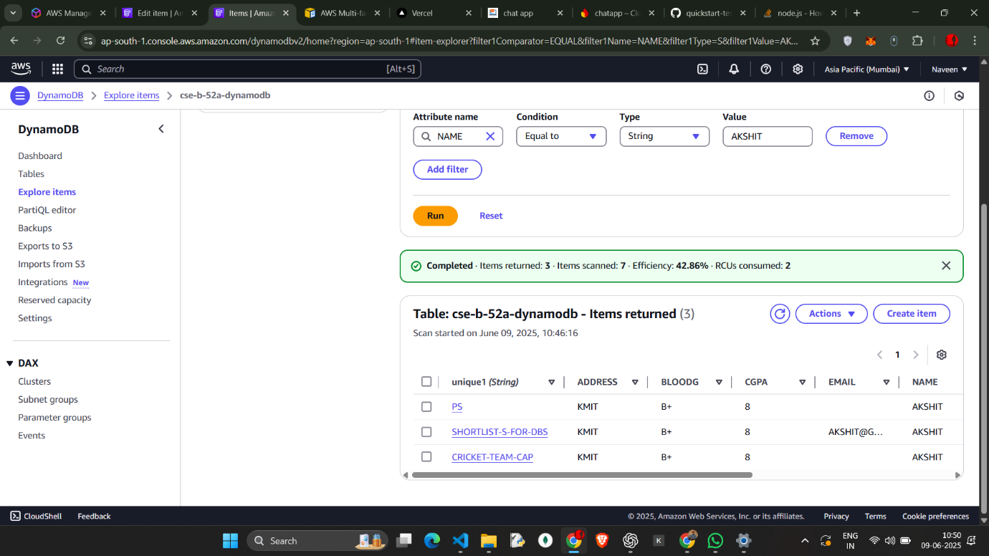

Name : akshith

And we will get the details of the items which matched with the value and the attributes

In scan we will get more than 2 tables

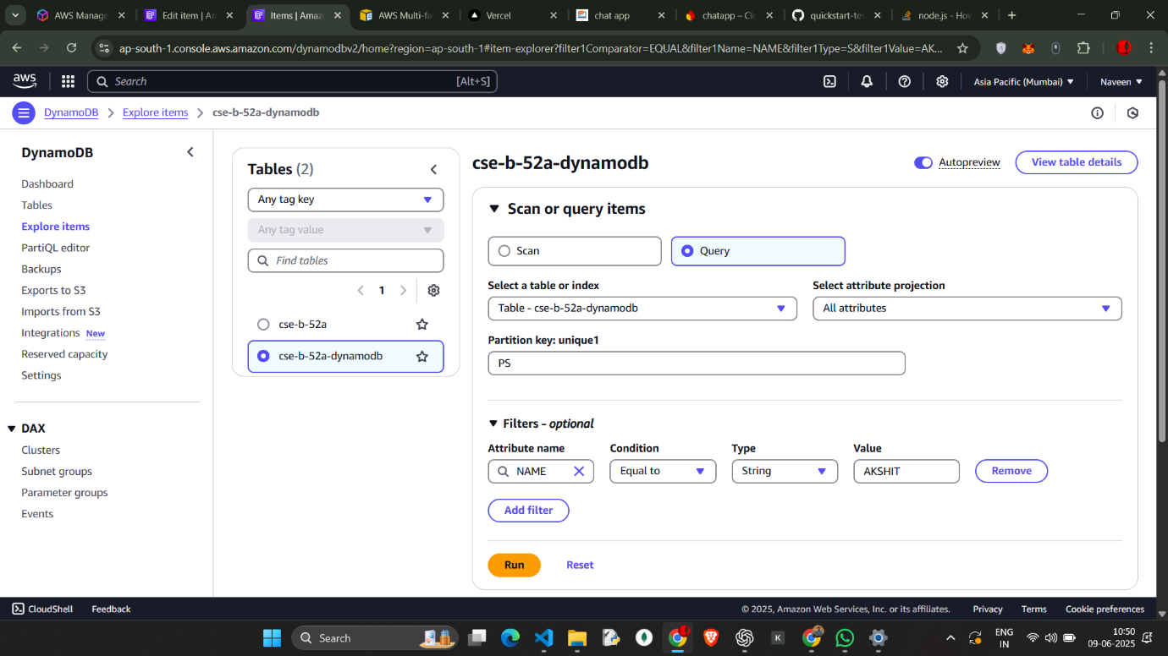

Select query

And unique1 is ps   
and add the filter

We will get only one item match with that filter data

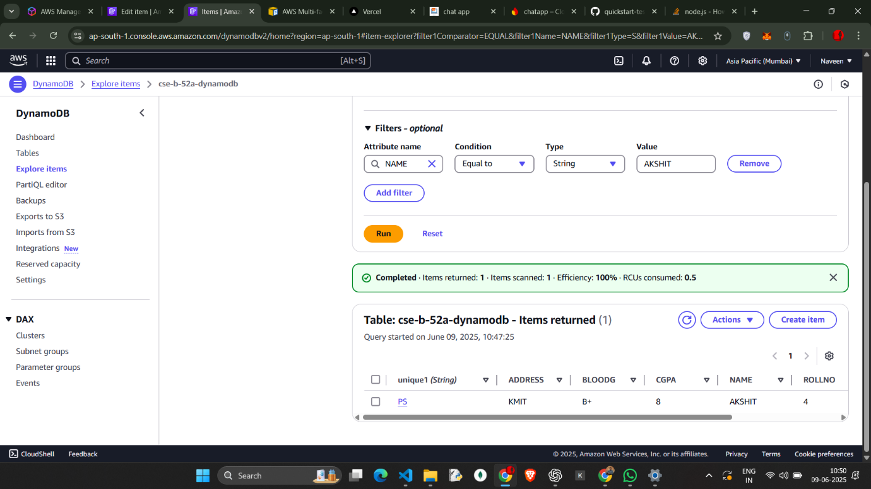

Perform some operations   
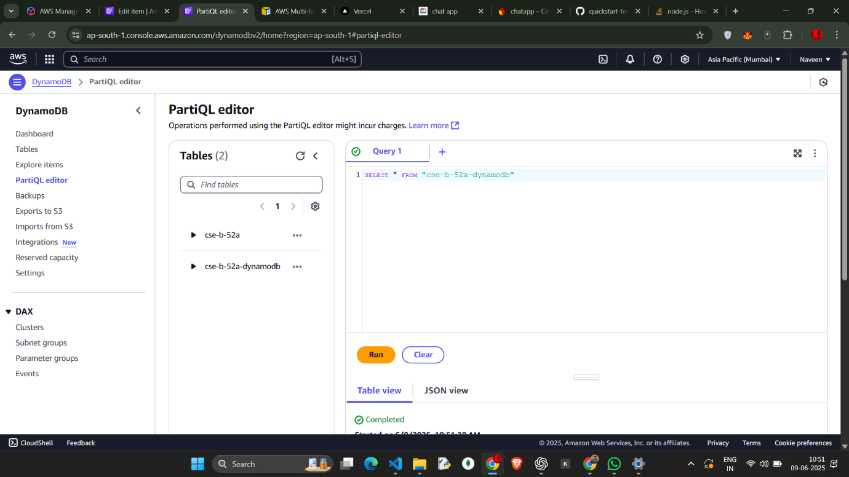

Out put

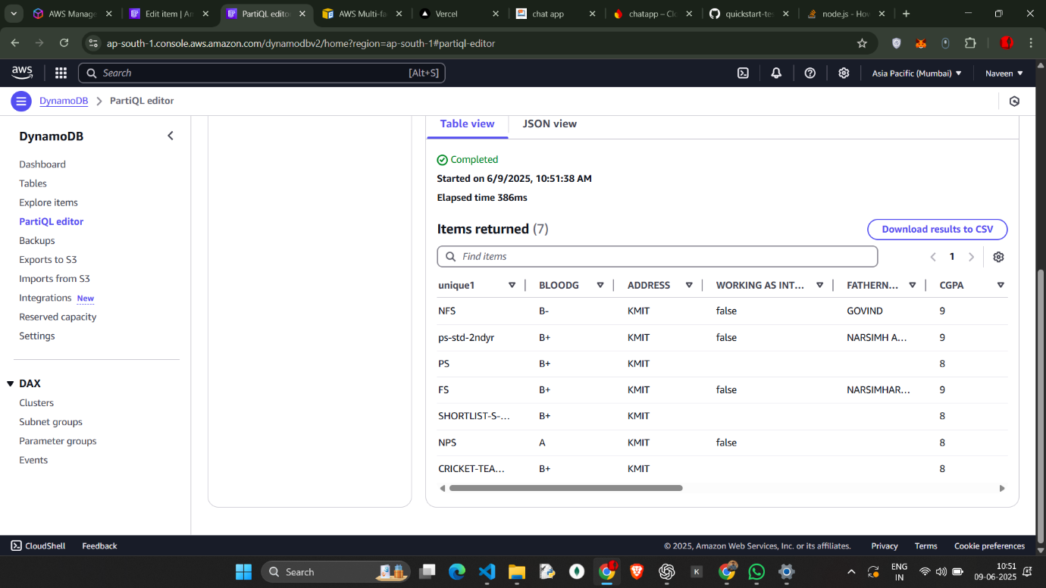

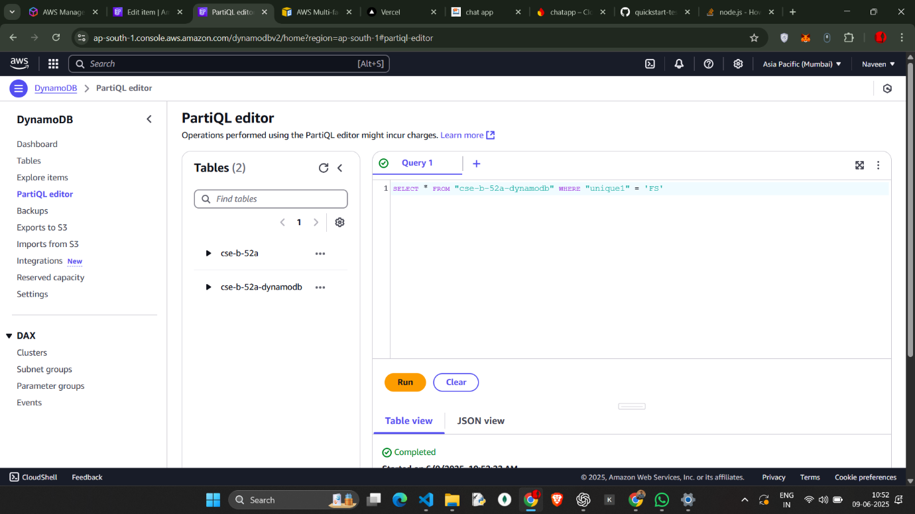

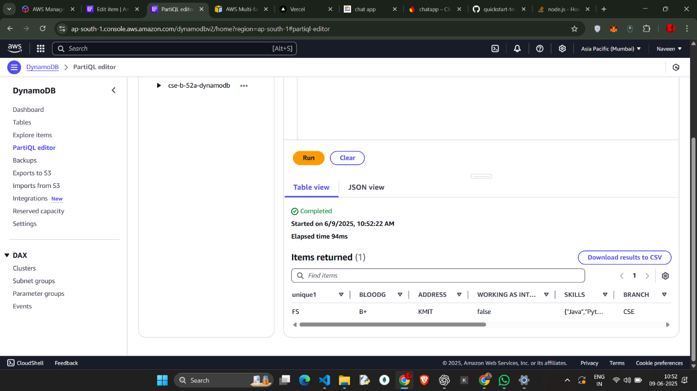

Output

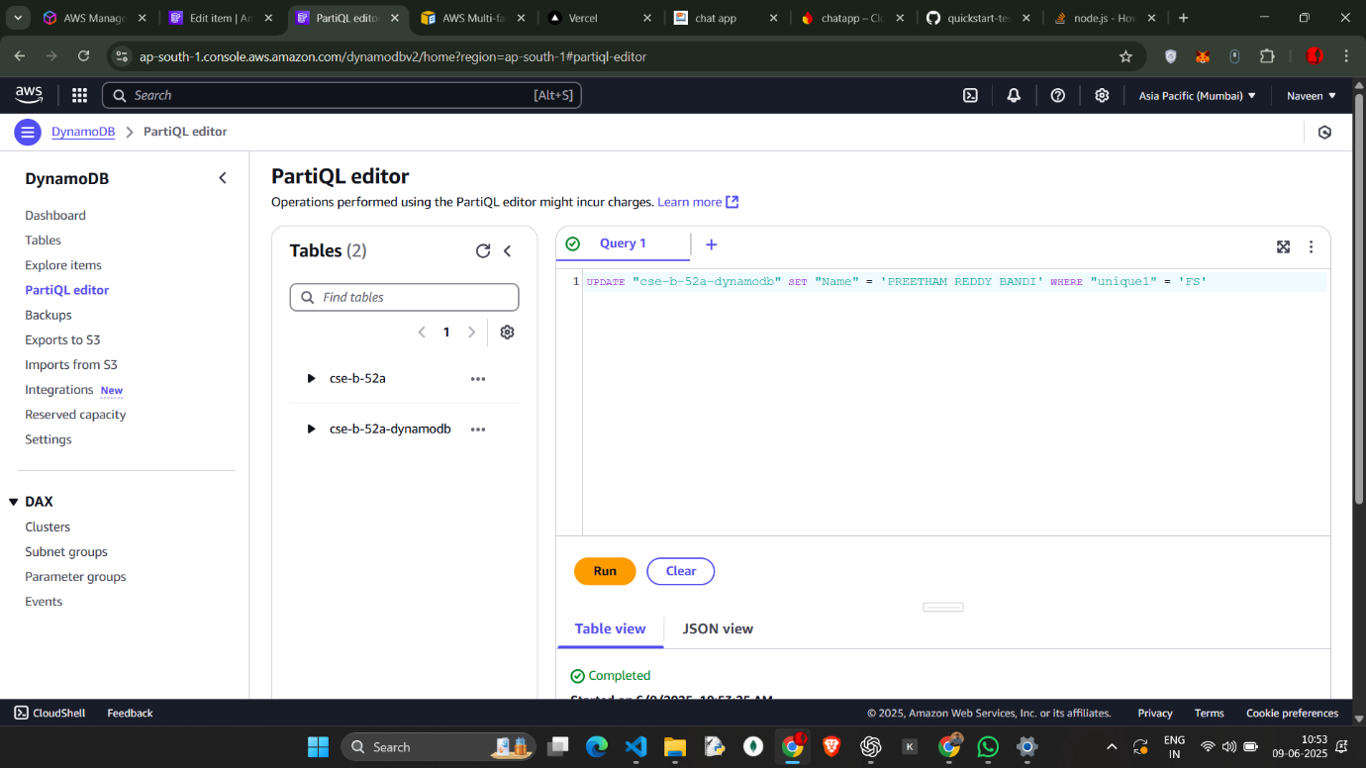

Data is updated

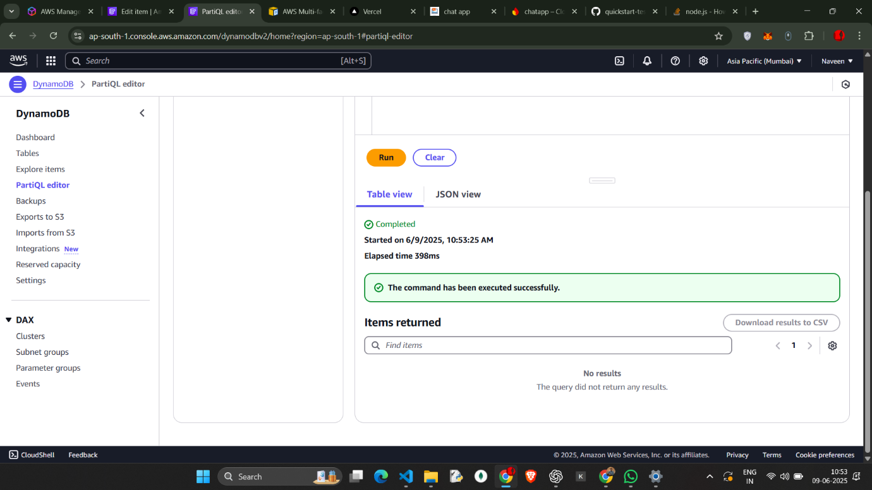

Delete the data

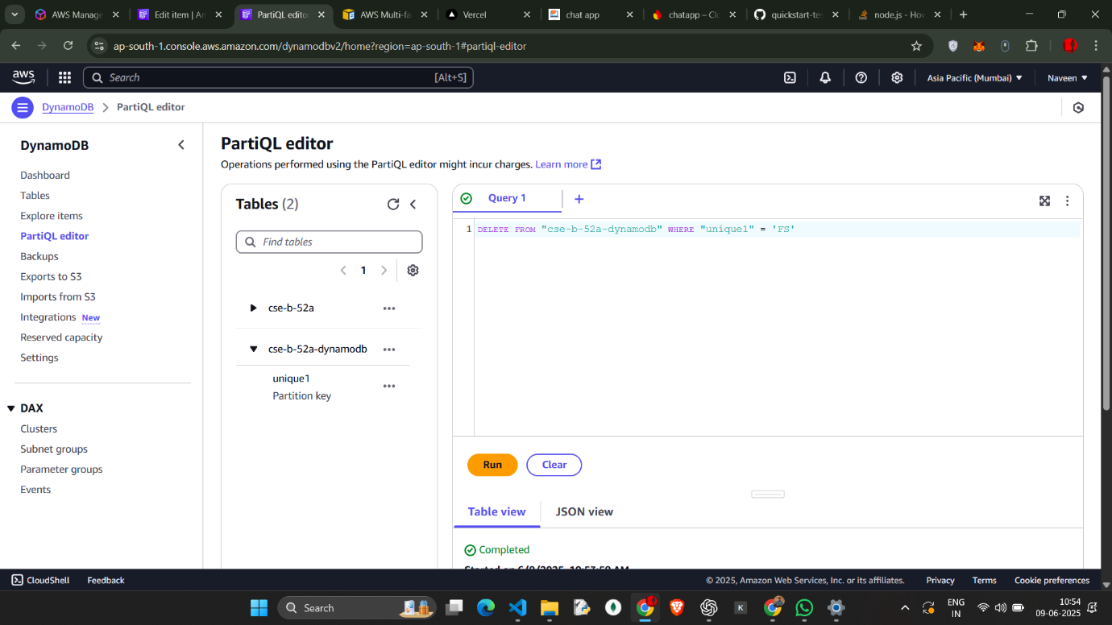

Deleted the item

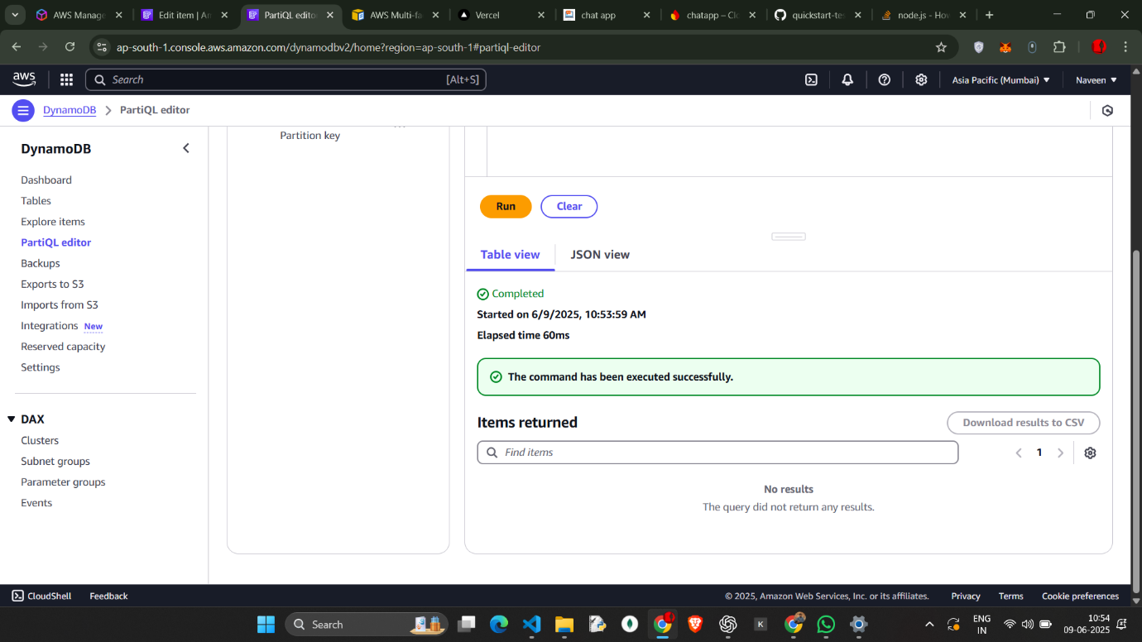

Go to Iam role and create the iam role

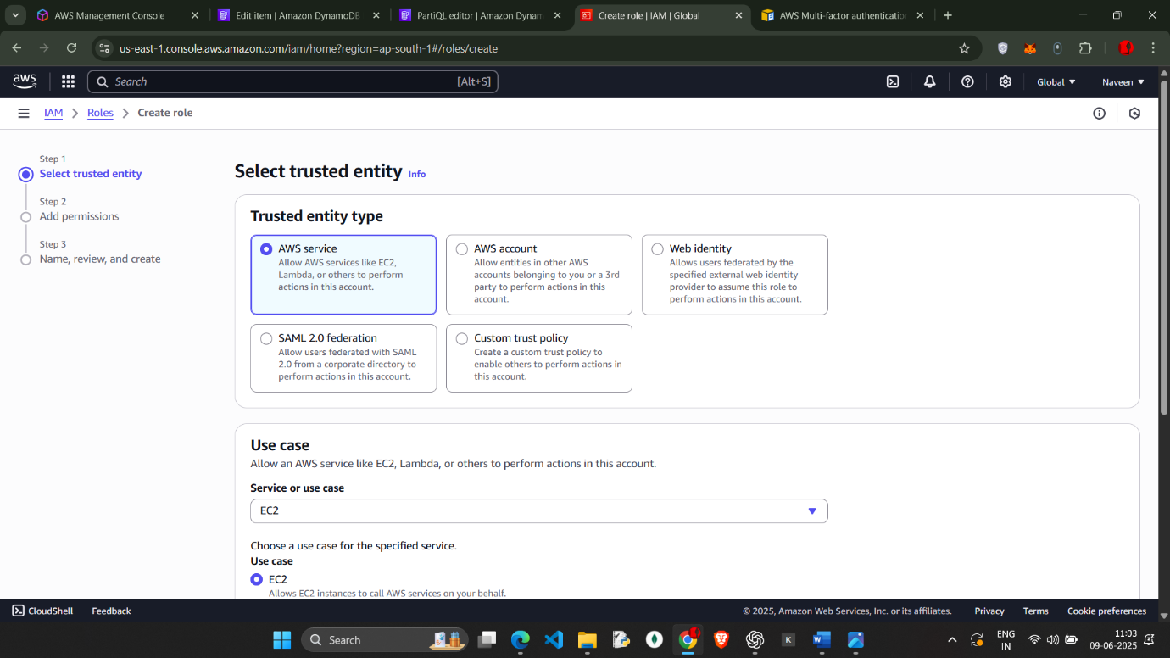

Give aws ec2 full access

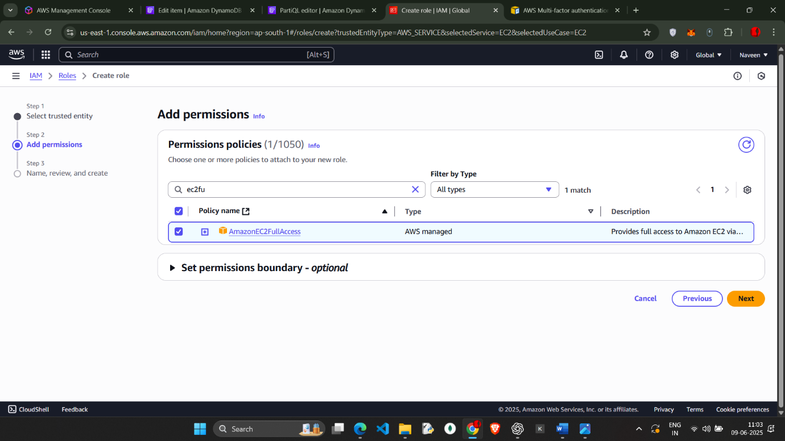

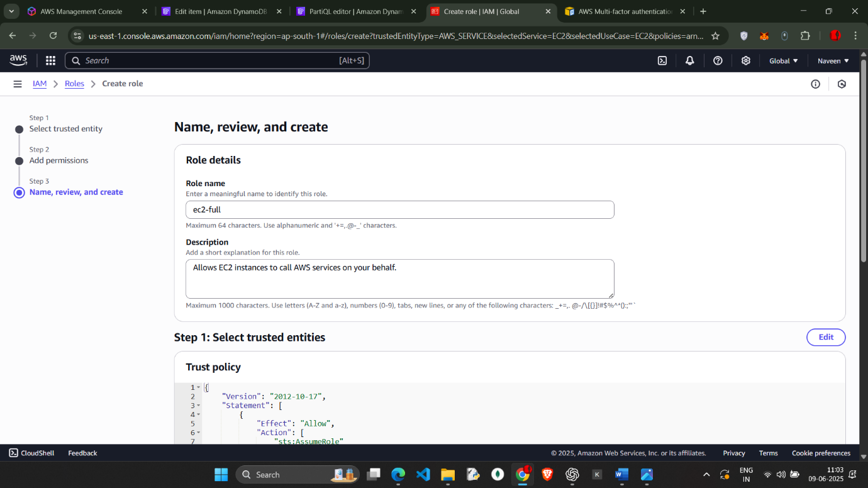

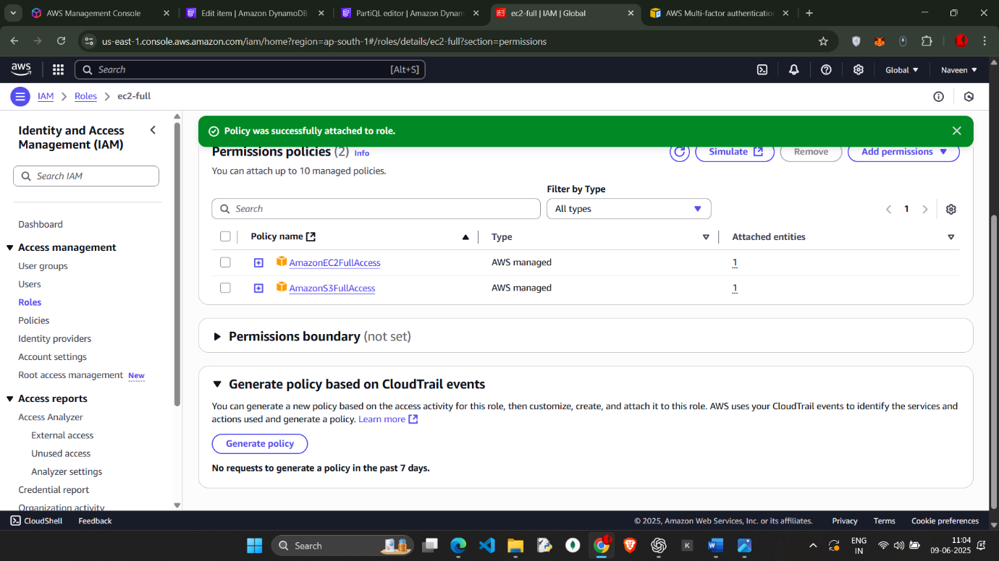

Attach the s3 full access in permissions

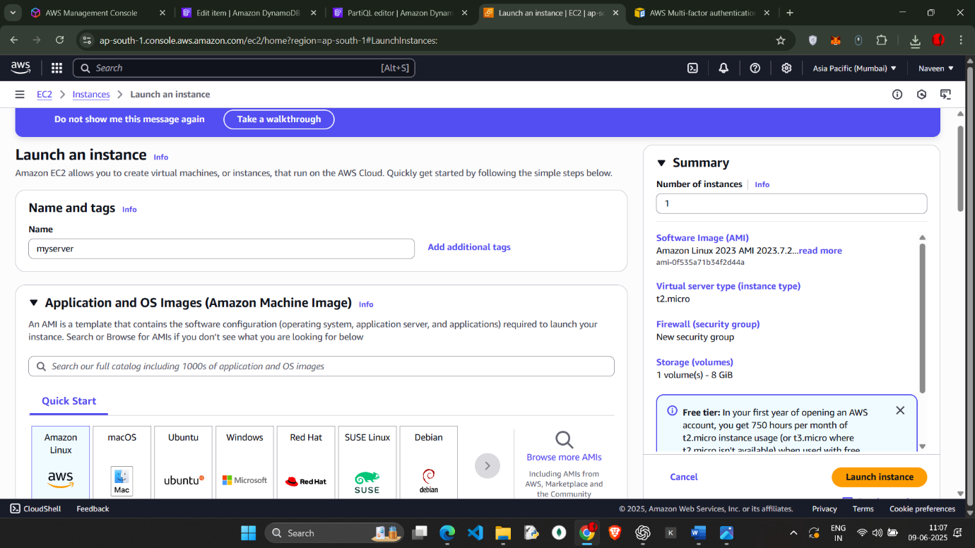

Launch the ec2 instance

And go to actions 🡪 security and add iam role update it

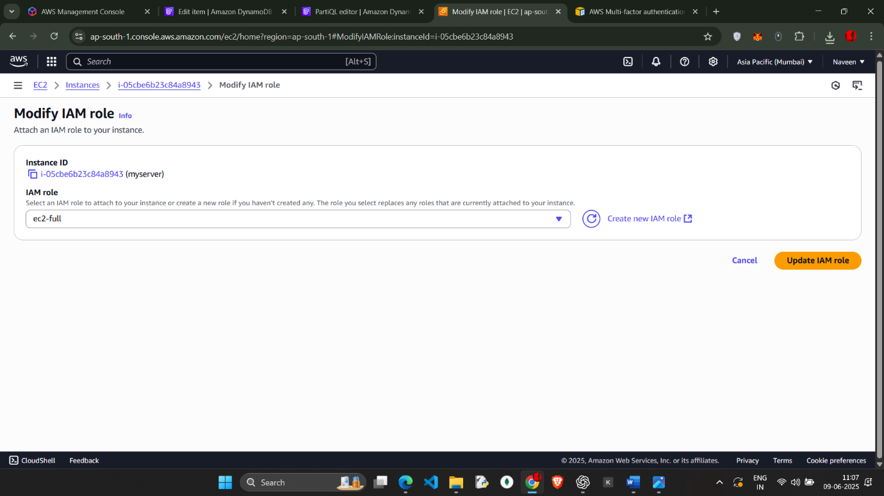

Go to command prompt and aws connect through pem ssh key

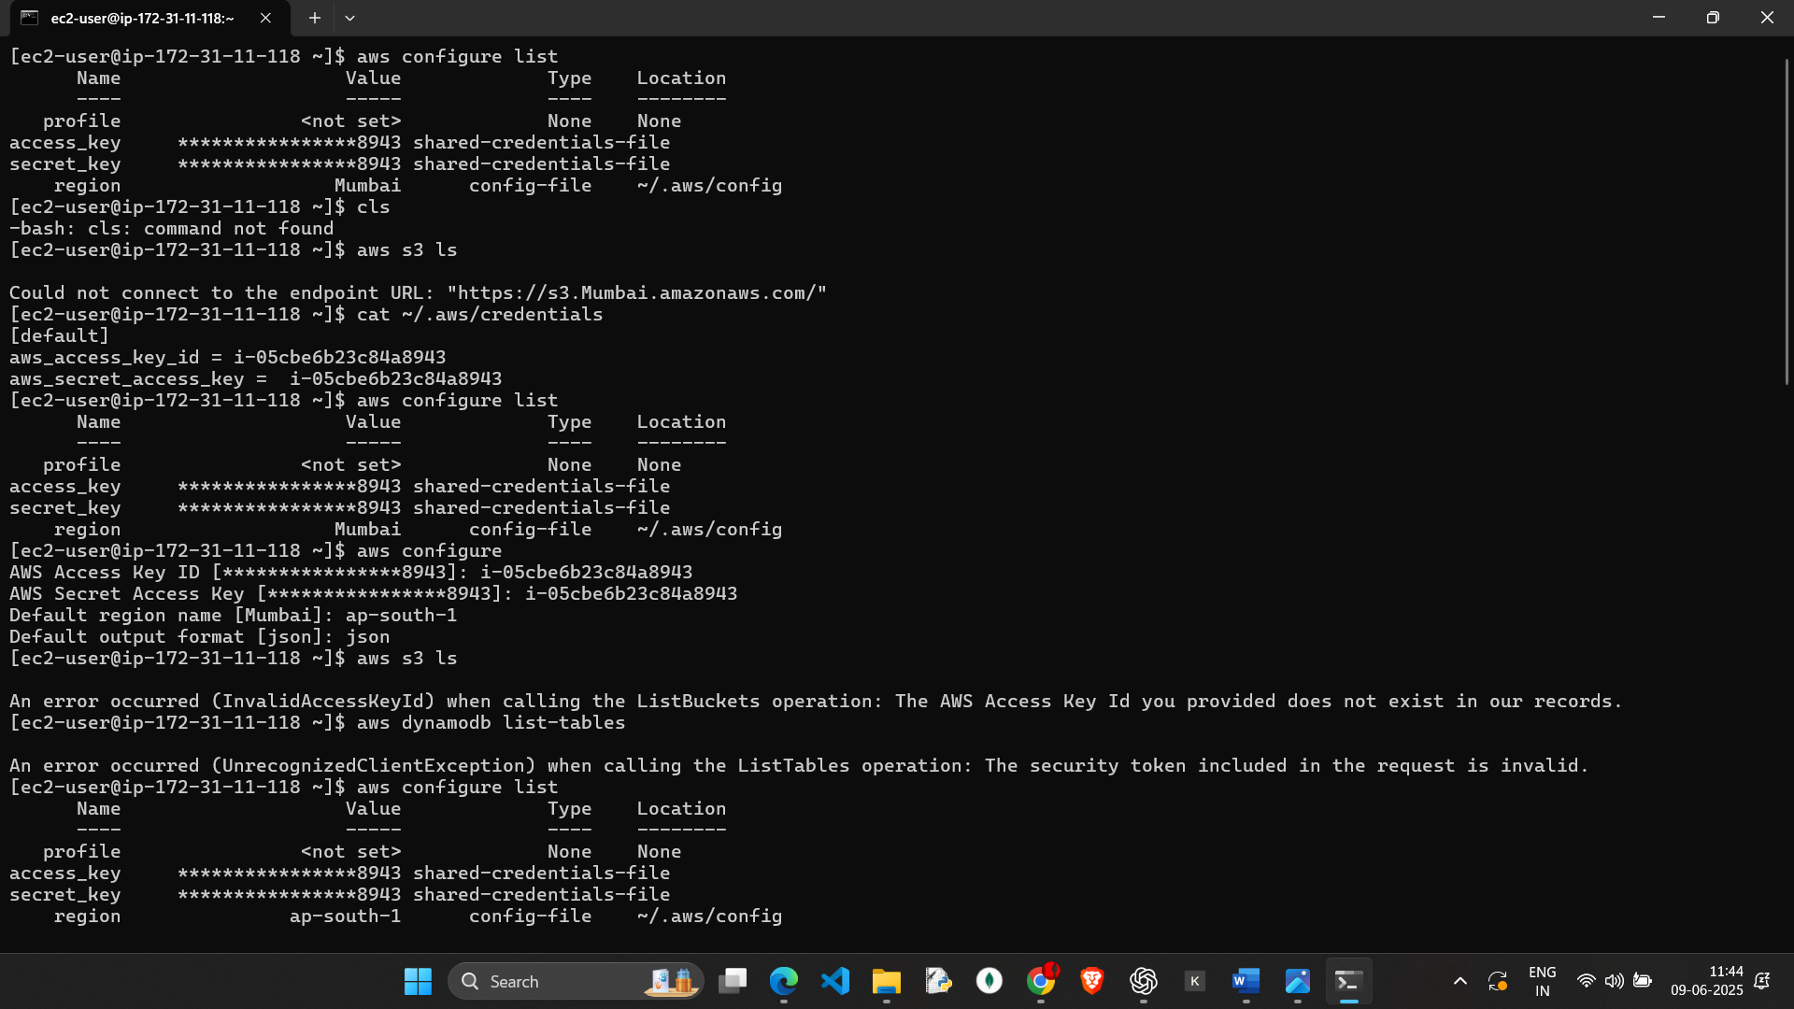check for aws s3 ls

And 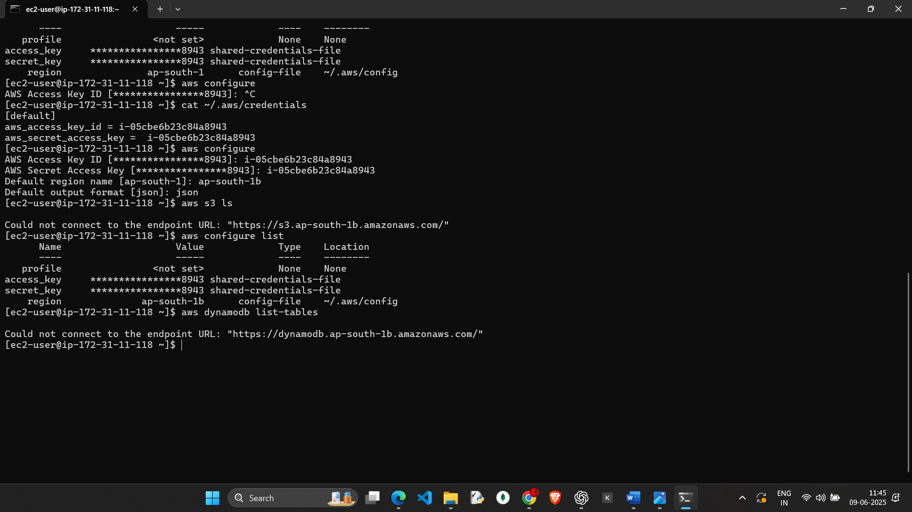dynamodb list-tables

We cant access it we cant find the tables